For Jim
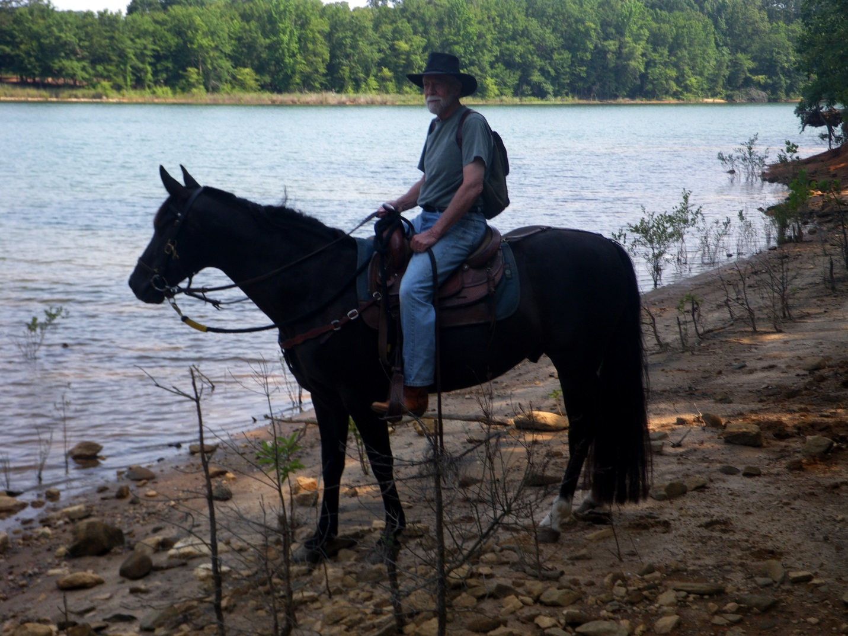

For my true friend Jim “Lonewalker” McClenahen: As I was growing up, my father would sometimes tell me that at the end of my life, I would be able to count my true friends on one hand. In those times, I did not like such words, but many decades later a true friend, about a decade older than I and now deceased, told me the same thing. I had lived and experienced enough to know the truth of it. Acquaintances, even lovers, come and go. Many are remembered, but only true friends are forever at the center of you. In part, you are who you are because they are a part of you, some of the best of you.
Monday afternoon, January 27, 2014, my true friend, Jim “Lonewalker” McClenahen, was transported from the Cleveland Clinic to his home and hospice care in Shreve, Ohio. Just a year ago he was cross-country skiing, snowshoeing and camping in the winter. He has annually canoed and backpacked everywhere from the southwestern deserts to the Rockies, Maine, the Lake States and Canada. Just last spring he was with me on one of our annual trail rides here in South Carolina. But by the end of the summer he had been diagnosed with an inoperable brain tumor. In the intervening months since then, I have repeatedly cried and prayed and prayed and cried “Oh, God, not Jim. Not Jim.” I should go first.
Jim and I are each other’s oldest, true friends. We started grad school together in the Penn State School of Forest Resources in September 1963. He was a native Pennsylvanian. I was a native Virginian. We hunted, fished, snowshoed, camped and canoed together. He was far and away the best woodsman I have ever known.
He was just married when we met. He was the best man at my wedding two years later. Years went by; we took different trails. We occasionally talked on the phone and then some years back we came together again. It was like we had never been apart for more than a week. We both knew we had never left the center of each other. I thank God for these years.
Jim has been a man who lived a full life everyday. He has been a loving and totally faithful husband. A loving and heroic father and grandfather that will leave a legacy few children ever experience. He has been a true friend to many people. I thank God that I am one of those people. When he crosses over, I want him to be one of my windwalkers until I join him and we walk and ride on the wind together, God willing.

*******
On March 10, 2014, my true friend passed into the infinite sweep of the arms of God. But he remains with all of us who loved him. I often feel his presence and, in my mind, I see him so young and healthy and with that easy smile and comforting chuckle.
*******

