In Memory of Danny
Gene W. Wood
July 5, 2016

My beautifully glistening black Danny (TWH Bo’s Danny Boy, 2004-2016) is physically gone from my life. I grieve both for what had been as well as for what can never be.
He was diagnosed with insulin resistance a few months ago. He had not been sound and rideable since early September 2015. He had had recurring laminitis for several years before that. After 9 1/2 months my excellent and very caring vet, Dr. Lindsay Wilkinson, Creek Run Vet Clinic, Pendleton, SC, and I decided on no more suffering. We had tried everything including special low starch diet, confinement completely to the barn lot with absolutely no fresh grass, special trimming and shoeing, and of course a steady diet of pain medication. After a new flare up of laminitis on June 21, for his sake, we put him down. His deep depression was resulting from continuous confinement. He was a prisoner of his disease. It was no life for a true trail horse like Danny.
Even with three other horses eating in the stalls, my barn seems strangely empty without him. He was the quietest horse I have ever owned - so willing, so beautiful and wearing my Windwalker brand. A horse for the trails no matter the grade, the tread, the weather, he was my total partner.
When I bought him at age 4 years, and only very green broke, I thought he surely would outlive me. It was not to be. As I write this, he pervades my entire being as a great and very special horse. No longer riddled with pain and depression, he truly walks on the wind where I will someday join him and other very special horses and dogs.

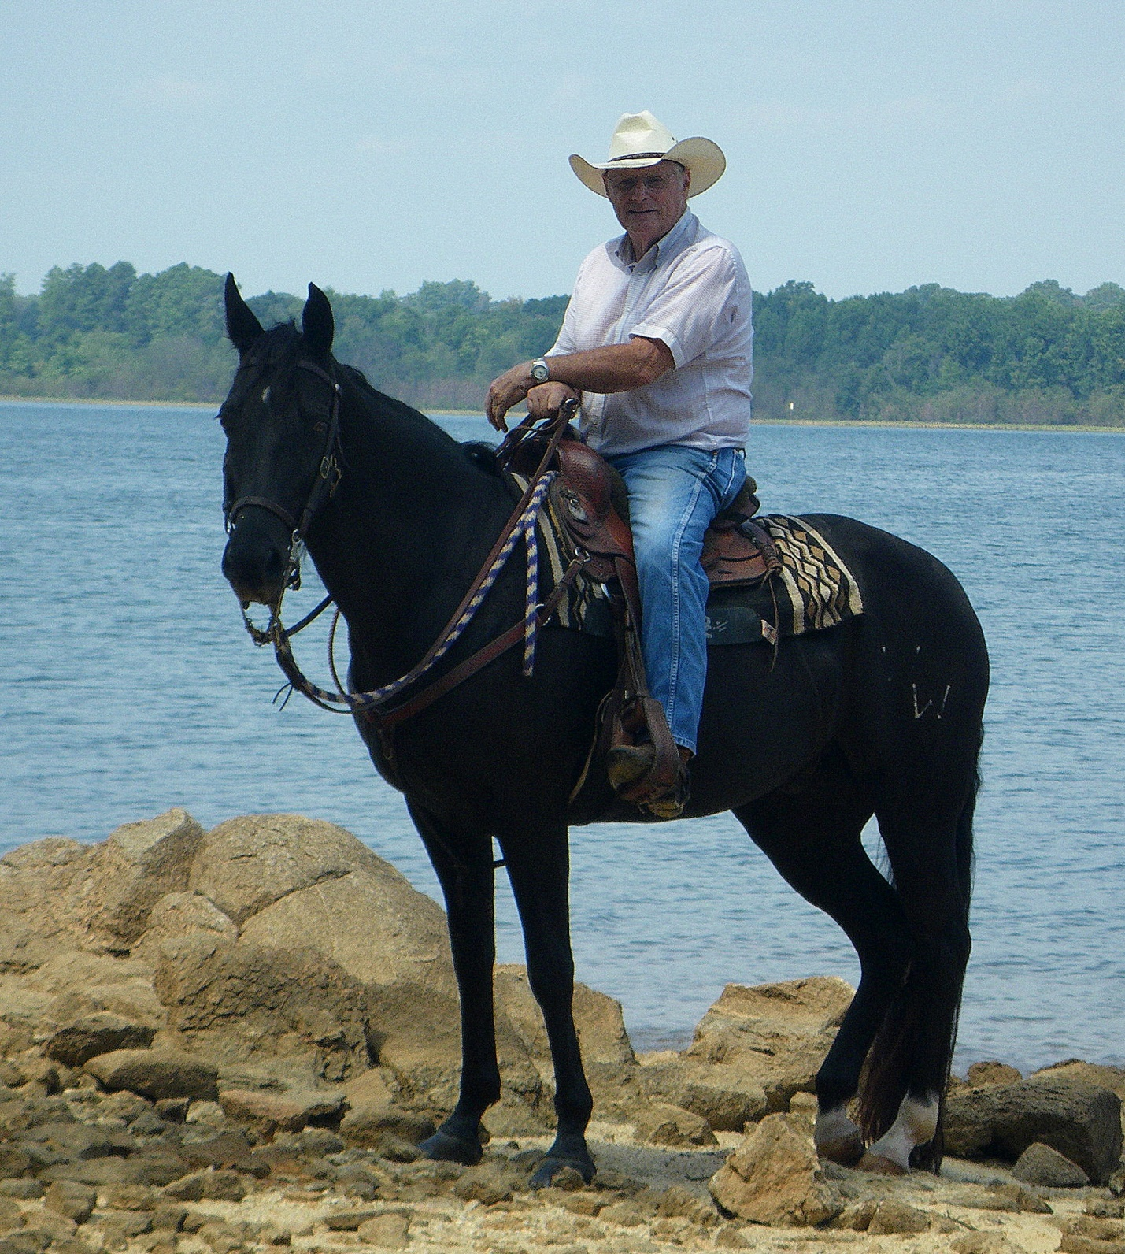
Danny and Gene, Lake Hartwell shoreline, Clemson Experimental Forest, Clemson University, August 30, 2014. (photo by Mike Pits)

